**DEVELOPMENT OF ANAEROBIC FERMENTATION VESSEL**

**FOR THE PROCESSING OF EXCELSA**

**COFFEE CHERRIES**

**CHAPTER I**

**INTRODUCTION**

Coffee is considered as a world’s black gold giving value to the lives of people. Additionally, the quality green coffee beans are considered a high value commodity that can worth from 150 to 200 pesos for Robusta, and 350 to 700 pesos for Arabica according to the Philippine Coffee Board. The market value of the green coffee beans ultimately depends on its quality. Normally, the quality is measured based on the number of defects after postharvest processing.

The postharvest processing of coffee cherries plays a vital role in the value chain of coffee. One of the crucial steps in the processing is the removal of the mucilage of the beans. The removal process will define the sensory properties of the green coffee beans. The conventional methods are the dry process and the wet process. Dry process is also called the natural process. This requires mostly a manual labor and the processing takes longer. Though, this process is less costly, the green coffee bean produced is not uniform in quality since the fermentation and drying relies on the conditions of the environment. Thus, wet process was devised and is preferred by most farmers. Wet process requires huge amount of water and machineries for processing from coffee cherries to green coffee beans. After depulping, the pulped cherries undergo fermentation process for 24 to 36 hours prior to sun drying. In comparison to dry process, the quality of green coffee bean produced by wet process is better. However, the main issue with the wet process is the control in the fermentation parameters (Lee, L.W., et al., 2015). Thus, this has caused a decline in the quality parameters of the green coffee bean processed. With these problems, new technologies in coffee processing arise. Among them are digestion method, carbonic maceration, and the anaerobic method.

Anaerobic fermentation, also called anaerobiosis, refers to the fermentation of coffee cherries under oxygen-deprived environment. The processing method of anaerobic fermentation is like the dry process and wet process, except that the fermentation is done in a closed container or bioreactor (da Mota et al., 2020; Martinez et al., 2021; Pereira et al., 2022). A bioreactor may be constructed from stainless steel (Martinez et al., 2021), a high-density plastic container (da Mota et al., 2020), or a plastic bag submerged in water (Mulyara & Rahmadian, 2021) with or without the addition of starter cultures such as *S. cerevisiae* and *T. debrueckii*.

In anaerobic fermentation, the duration varies between 16 and 90 hours. Fermentation time contribute to the flavor profile of the coffee beans. Longer fermentation duration of anaerobic fermentation compared to that of wet process may contribute to the enhanced formation of flavor precursors, increasing the formation of Maillard-related flavors during the roasting process. A previous study by Martinez et al. (2021) showed that furans, acids, and pyrazines dominated the volatiles of anaerobic fermentation-roasted coffee beans. These are the compounds that contributed to the notes of caramel, chocolate, and acidic flavor of the roasted beans. Prolonged yeast fermentation may also contribute to formation of esters, a compound that intensify the fruity property of the processed coffee from anaerobic fermentation (Martinez et al., 2021). Additionally, the use of closed bioreactor offered some advantages to the process especially on the control of important parameters such as temperature, aeration, and stirring treatment. However, since in this method, the fermentation duration is relatively longer compared to dry process and wet process, the drying process should be done in a timely manner to avoid over-fermentation.

This study aims to develop an anaerobic fermentation vessel for the processing of Excelsa coffee cherries.

Specifically, this study has the following objectives:

1. Assess the conventional postharvest processing of coffee producers and farmers;

2. Determine the performance of coffee fermentation bags based on different

a. packaging type

b. pre-treatment of pulped beans

c. temperature

d. fermentation time

3. Monitor and model the following fermentation characteristics.

a. anaerobic respiration rate

b. temperature profile

c. pH profile

d. total soluble solids profile

3. Determine the quality parameters of the green coffee bean produced

a. color

b. uniformity

c. grade

4. Determine the quality parameters of the roasted coffee bean produced based on the following.

a. pH

b. total soluble solids

c. coffee cupping score

6. Conduct economic analysis for the coffee fermentation bags.

**REVIEW OF LITERATURE CITED**

This section presents the literatures and baseline information related to the study. In the preliminary section, the status of coffee market in the country is discussed. The data on the production per variety and per region are also presented, respectively. To understand the process from production to postharvest, the coffee value chain is presented.

The section on the coffee processing introduces the main concept of this study. This discusses the conventional methods in the postharvest processing of coffee cherries. Anaerobic fermentation process is one of the emerging technologies, not only for the removal of mucilage, yet to produce quality green coffee beans.

**Coffee Market in the Philippines**

Coffee is one of the high-value crops of the Philippine agriculture. According to Philippine Statistics Authority, coffee production in the Philippines has been decreasing by 3.5% annually for the past 10 years while the coffee consumption has increased by 8.8%. Based on the comprehensive study conducted by the Department of Agriculture, small farmers are the main coffee producers in the country. The farm is considered as smallholder farm when the farmer owned the 1.5 hectares or less plantation intercropped with either fruit trees or coconut or both.

On the first quarter of 2023, the production of green coffee beans has increased by 1.3% compared to the first quarter of 2022. As shown in the Figure 1, Robusta dominated the coffee production with the share of 73.5%. It is followed by Arabica, which is considered the premium variety, of 18.6%. Excelsa and Liberica varieties comprised of 7.4% and 0.6%, respectively (Philippine Statistics Authority, 2023).

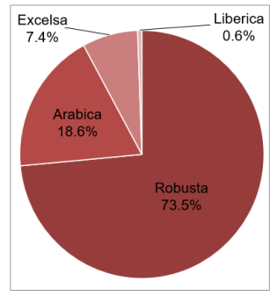

Figure 1. Coffee Production in terms of Variety (PSA, 2023)

In terms of regional production, SOCSKSARGEN dominated the Philippine market with a 33.4% share to the total production. It is followed by Northern Mindanao and Davao Region with the market share of 13.7% and 12.3%, respectively. CALABARZON constitute the 7.93% of the total share as shown in Figure 2 (Philippine Statistics Authority, 2023).

The data above are green coffee bean (GCB) production. GCB are processed bean from the coffee cherries. After harvest, coffee cherries undergo series of unit operations to produce the quality green coffee beans. To understand the unit operations involved, we will study the coffee value chain.

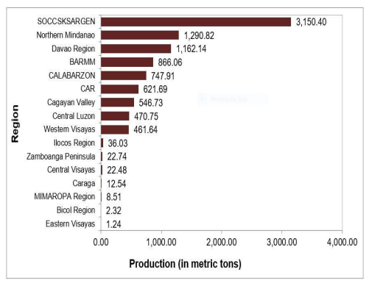

Figure 2. Coffee Production in terms of Region (PSA, 2023)

**Coffee Value Chain**

The start of the value chain is with the input. This comprises the selection of the resources in preparation of the production such as planting materials, labor force, fertilizers, farm location, and many other considerations. The major challenge in this phase is the poor-quality planting materials. If in this early stage, the quality has been compromised, the rest of the chain will be affected. The intervention cited in the procurement of the coffee seedlings to Bureau of Plant Industry-registered nursery, the supplementation of proper fertilizer for the soil, and consideration of the farm topography and agro-climatic requirements to the coffee variety to be planted.

Coffee production is a crucial stage of the value chain. The coffee plant should be taken with so much consideration from the propagation to harvest. The seed sowing is usually done during the month of November. This is seven (7) months from the rainy season, which is the time of transplanting. It takes three years for the seedling to bear fruits from transplanting through seed planting or sexual method. However, the mother plant can be grafted. This method is known as asexual method, vegetative propagation, or cloning. The coffee plant is raised through nodal cuttings. By this method, it only takes 18 months for the plant to bear fruits after transplanting.

Figure 3. Coffee Value Chain

Postharvest stage is the conversion of the coffee cherry into green coffee bean after its harvest from the coffee plant. From the harvest, the cherries undergo the process of flotation. Flotation is the separation of the good quality cherries from bad quality cherries using buoyancy. The sinkers will proceed to processing while the floaters will be separated and will not be allowed to proceed in the succeeding unit operations. The sinkers will then undergo fermentation to remove the mucilage from the coffee bean. The processing methods include the dry process, semi-washed process, washed or wet process, and the honey process. Each process will have a succeeding separate discussion since this is the focus of this study.

Once the beans are processed, the next step is to distribute them to the target markets. The coffee markets are the segmented into different forms such as distributors, retailers, or café owners. From the market, the roasted beans and brewed coffee will reach to the consumers.

**Processing of Coffee Cherries**

The processing of coffee cherries is done to separate the skin, pulp, and mucilage. There are four traditional methods of processing; namely, the natural process, the honey process, the pulped natural, and the wet process (Poltronieri & Rossi, 2016). These processing methods depends on the regional climatic characteristics. For regions with dry climate, the usual processes are natural and honey; while pulped natural and wet processes are conducted for wet climate regions. Figure 4 shows the coffee cherry processing methods depending on the regional climatic characteristics.

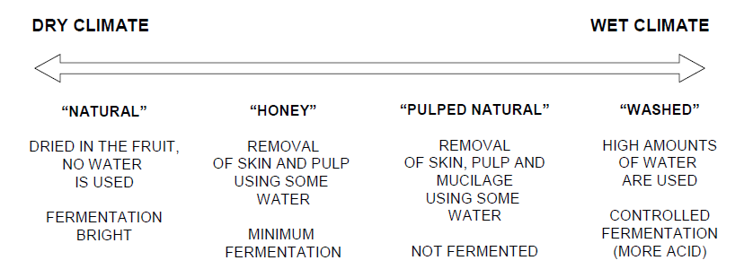

Figure 4. Coffee Cherry Processing Methods (Poltronieri, P. and Rossi, F., 2016)

**Natural Dry Process**

This process is considered as the oldest and the simplest method which requires mostly a manual work. The three basic steps in dry process are the cleaning, drying, and hulling (Batista, et. Al, 2016). The initial step of the process is to clean and to sort the harvested cherries. This is can done through winnowing and flotation. Winnowing is a process of sieving to separate the foreign particles from the coffee cherries while flotation is the process of separation through density. Flotation is used to determine the ripe, unripe, or damaged cherries from the good coffee cherries. Once the cherries are sorted, they will undergo sun-drying or mechanical drying until the moisture content reaches 12.5%. Sun drying is done on a drying mat or concrete patios. The dried cherries are then stored into silos and sent to the mill for hulling, grading, and bagging.

**Wet Process**

This process requires large amount of water and machines to process the harvested coffee cherries. The same with the natural process, the initial step is to clean and to sort the harvested cherries. After the sorting and cleaning, the cherries are pulped using the depulper machine. The pulping is done by squeezing the cherry separating the skin and the pulp from the bean enclosed with the mucilaginous parchment covering. Pulping is done immediately after harvesting to avoid the coffee cherry deterioration. After the pulping process, the pulped beans undergo sorting through sieving. In this manner, the unpulped and imperfectly pulped will be separated for them to undergo the pulping process again. On the other hand, the pulped beans will undergo flotation method through the water channels after the sieving to further separation process. These pulped beans then undergo fermentation process in the fermentation tanks in which mucilage is removed through natural or microbial enzymes. The fermentation process varies depending on the system temperature, the layer of the mucilage, and the concentration or type of enzymes. It usually takes place at a range of 24 hours to 36 hours. Once the fermentation is done, the beans are washed properly and then dried through sun drying or mechanical drying to 12.5% (Batista, et. Al, 2016). After drying, the beans undergo hulling, cleaning, sorting, and grading before distribution to the market. This series of operations are also called curing.

Though this process has been used for how many years, the main issue using this process is the control on the fermentation parameters (Lee, L.W., et al., 2015). Thus, this has caused a decline in the quality parameters of the green coffee bean processed.

**Pulped Natural Process**

This process is a combination of the wet and dry process. The removal of pulp is done by wet process through mechanical method. One the pulp is removed; the beans are allowed to be fermented through dry process in a cemented patios by thin layer sun drying. Further studies need to be conducted showing the effect of this postharvest process to the quality parameters of green coffee beans and the sensory parameters of the roasted coffee beans. However, this process is usually undertaken to produce espresso blends.

**Honey Process**

This process makes use of mechanical depulpers to remove skin and pulp. The amounts of mucilage vary from 20% to 80%. The depulped beans are dried through sun drying obtaining yellow, red and black honey coffee as shown in Figure 5. These quality coffee beans are also described in terms of percentage of honey level. A yellow honey coffee is composed of approximately 25% mucilage. This type is more exposed to the sunlight; thus, the drying time is shorter which is about 8 days. The red honey is composed by approximately 50% mucilage. The drying time takes about 12 days under cloud cover or shading. Black honey is usually 100% covered by mucilage. Its composition of higher mucilage covering prolongs the drying period to about 30 days.

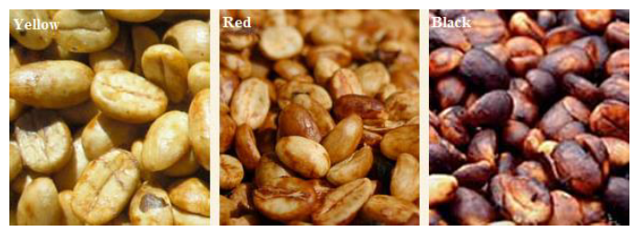

Figure 5. Appearance of Honey Processed Green Coffee Beans (Poltronieri, P. and Rossi, F., 2016)

**Emerging Technologies in Coffee Processing**

The emerging technologies covered are animal digestion, carbonic maceration, and anaerobic digestion. Each technology will be discussed in detail to respective sections.

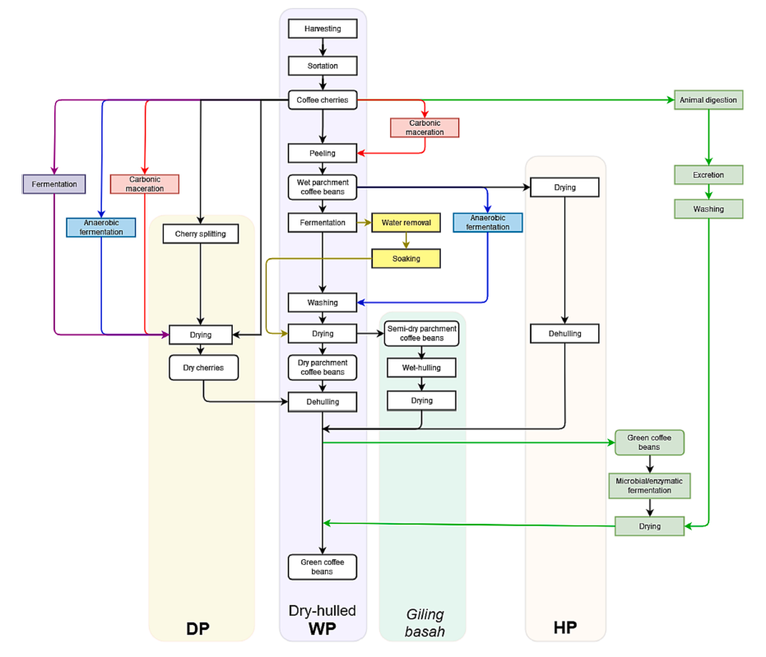

Figure 6. Emerging Technologies in Processing Green Coffee Beans

(Febriento, N. and Zhu, F., 2023)

**Digestion Method**

This method involves animals, enzymes from the digestive system of animals, or utilization of commercial enzymes for coffee bean processing (Febriento, N. and Zhu, F., 2023). These coffee beans are considered as specialty coffee since they have high quality sensory properties and are high value. Among them are civet coffee or locally known as Kopi luwak in Indonesia. In the Philippines, civet coffee is produced by civet cats (Paradoxurus philippinensis) where one of the natural habitats can be found in Mt. Matutum in South Cotabato province. Other coffee beans from digestion method are ivory coffee beans, which are product of digestion by the elephants in Thailand, the jacu coffee beans which are ingested and excreted by jacu birds in Brazil and in some parts of Norway, and the monkey parchment coffee beans which are eaten and spat out Arabica coffee cherries by Rhesus monkeys from parts of India.

There are several factors affecting the quality of naturally digested coffee beans. It is the instinct of these animals that allows them to get the best coffee cherries for consumption. Thus, ensuring the optimal conditions of coffee cherries to be harvested. The coffee cherries are consumed either peeled or whole for digestion for up to 70 hours in the animal digestive tract (Raveendran & Murthy, 2021). The indigested beans are excreted by the animals and are then collected for washing and drying. The combination of microbiota and enzymes in the animal digestive system is one of the most influential factors affecting the quality of the coffee beans. There are differences in the quality between the wild civet coffee beans and the caged civet coffee beans. This is mainly due to the differences in the habitual diets of the animals affecting their digestive systems (Febrina, Happyana, & Syah, 2021). These factors are the causes of the high variability in the quality of the coffee beans from digestion method. The schematic process of the digestion method is shown in Figure 6.

**Carbonic maceration**

Carbonic maceration is a method in coffee bean processing in which the fermentation process is under a CO2 rich environment (Tesniere & Flanzy, 2011). The coffee cherries are initially stored in a bioreactor, where the air inside is removed via suction or vacuum. Then, the CO2 is injected into the reactor to obtain the environment with the suitable CO2 level (Junior et al., 2021; Tesniere & Flanzy, 2011). The reactor is incubated from 24 to 120 h at 18 to 38°C. The fermented cherries are further processed using either the dry process, wet process, or honey process. Yet, the combination of the carbonic maceration and dry process on Arabica coffee cherries showed that fermentation for about 120 hours at high temperature produced coffee beans with optimum sensory properties (Junior et al., 2021).

The brewed coffee from the beans treated with carbonic maceration and dry process had a high sensory score of *>* 80 which is considered a specialty coffee. The beans incubated at 38 °C for 120 hours had the highest score of 85.15 which is considered as excellent grade specialty coffee (Junior et al., 2021). This was related to the suitable bacterial diversity during fermentation at optimum temperature. Junior et al. (2021) found that the temperature of 38 °C provided suitable environment for bacteria growth since the early stage of fermentation. Hence, the production of flavor metabolites from the fermentation was maximized, resulting in improved fragrance and aftertaste attributes. However, since there was no comparison with non-carbonic maceration-treated dry processed coffee beans of the same origin, the extent of improvement contributed by carbonic maceration treatment toward current processing remains to be studied.

**Anaerobic Fermentation**

Anaerobic fermentation, also called anaerobiosis, refers to the fermentation of coffee cherries under oxygen-deprived environment. The processing method of anaerobic fermentation is like the dry process and wet process, except that the fermentation is done in a closed container or bioreactor (da Mota et al., 2020; Martinez et al., 2021; Pereira et al., 2022). A bioreactor may be constructed from stainless steel (Martinez et al., 2021), a high-density plastic container (da Mota et al., 2020), or a plastic bag submerged in water (Mulyara & Rahmadian, 2021) with or without the addition of starter cultures such as *S. cerevisiae* and *T. debrueckii*.

In anaerobic fermentation, the duration varies between 16 and 90 hours. Based on the study of Pereira et al. (2022), the microbial diversity of the coffee beans in the anaerobic fermentation method was mainly composed of yeast, and the mesophilic and lactic acid bacteria. Among the microorganisms, *Hansemiaspora opuntiae*, *S. cerevisiae, Lactiplantibacillus plantarum, Staphylococcus warneri, Levilactobacillus brevis, Weisella cibaria, Leuconostoc mesenteroides, Candida glabrata,* and *Bacillus subtilis* were dominant in anaerobic fermentation-processed coffee cherries and pulped beans.

The processing of the coffee beans in a modified atmosphere environment such as anaerobic fermentation and carbonic maceration induces changes in the chemical composition by three mechanisms, namely, the changes in the consortium of microorganisms, in the metabolisms of microorganisms, and in the metabolisms of the coffee cherries or beans. Oxygen-deprived conditions limit the growth of aerobic microorganisms. On the other hand, yeast and bacteria can survive anaerobic conditions despite their changes in metabolisms. Anaerobic conditions optimize ethanol production by yeast, especially *S. cerevisiae* (Huang & Tang, 2007). Meanwhile, lactate is produced by lactic acid bacteria mainly via the lactate dehydrogenase pathway under anaerobic conditions (G¨anzle, 2015). In the plant tissue and fruits, the cells switch to anaerobic glycolysis to compensate for the lack of aerobic energy. These fermentative pathways can cause the acidification of the cytoplasm and the production of ethanol, alanine, malate, and succinate from pyruvate (Benkeblia, 2021). Depending on the tolerance of the plants, anaerobic conditions may limit the breakdown of starch (Benkeblia, 2021).

A prolonged fermentation period involving only bacteria and yeast may be the most important feature in the anaerobic fermentation method. The oxygen-deprived condition is unfavorable for the growth of filamentous fungi such as *Aspergillus* and *Penicillium*, hence optimizing the metabolism of bacteria and yeast. It was founded by da Mota et al. (2020) that natural and inoculated anaerobic fermentation increased the temperature from 18 °C in the beginning, 22 °C in the middle, and 30 °C at the end of fermentation. The higher temperature at the end of fermentation may lead to optimum microorganism activities. Martins et al. (2020) and Pereira et al. (2022) found that anaerobic fermentation increased bacterial activity, resulting in more bacterial metabolites. These bacterial metabolites and anaerobic conditions restricted fungal infections that caused over-fermentation. Over-fermentation in aerobic fermentation of coffee beans is indicated by the presence of mold and filamentous fungi (Ismayadi et al., 2005; Maman et al., 2021; Sulaiman, Erfiza, & Moulana, 2021). They contribute to the occurrence of off-flavors (musty, earthy, and moldy) and harmful substances such as aflatoxins (Ismayadi et al., 2005; Maman et al., 2021; Sulaiman et al., 2021). Fermentation time contribute to the flavor profile of the coffee beans. Longer fermentation duration of anaerobic fermentation compared to that of wet process may contribute to the enhanced formation of flavor precursors, increasing the formation of Maillard-related flavors during the roasting process. Maillard reaction is a non-enzymatic reaction takes place between reducing sugar and free amine in food products which alters their organoleptic properties (Kathuria, D., et al., 2023).

A previous study by Martinez et al. (2021) showed that furans, acids, and pyrazines dominated the volatiles of anaerobic fermentation-roasted coffee beans. These are the compounds that contributed to the notes of caramel, chocolate, and acidic flavor of the roasted beans. Prolonged yeast fermentation may also contribute to formation of esters, a compound that intensify the fruity property of the processed coffee from anaerobic fermentation (Martinez et al., 2021).

The use of closed bioreactor offered some advantages to the process especially on the control of important parameters such as temperature, aeration, and stirring treatment. However, since in this method, the fermentation duration is relatively longer compared to dry process and wet process, the drying process should be done in a timely manner to avoid over-fermentation.

**Methodology**

This section discusses the conceptual framework of the research study. This will also cover the materials needed for the study, as well as the specific methods to be undertaken for each specific objective. This section also presents the workplan and the budgetary requirements.

**Conceptual Framework**

The conceptual framework presents the summary of the study. This shows the input, the process, the output, and the outcome of each objective. Inputs are materials, skills, instruments, or knowledge needed for the conduct of the study.

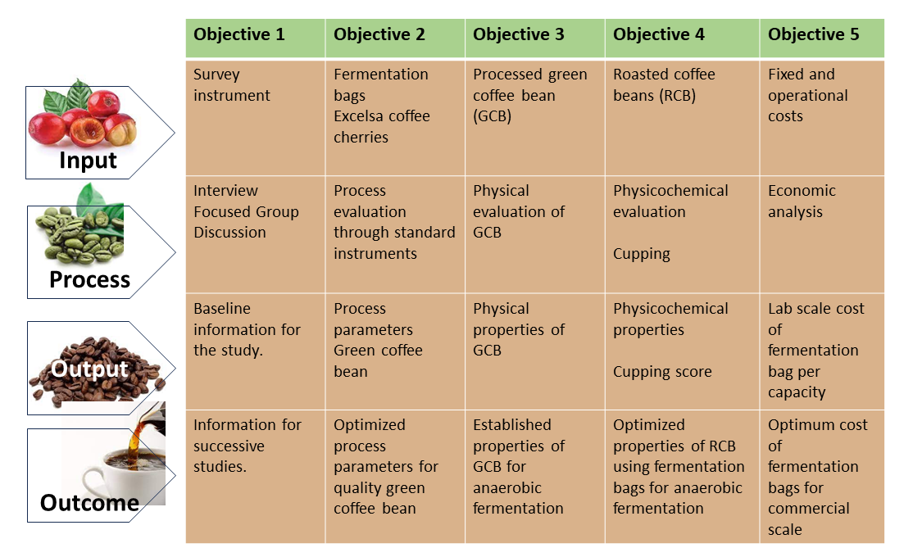

Figure 7. Conceptual Framework of the Study

**Design of Coffee Fermentation Bags**

There are two types of fermentation bags to be tested. One bag is made of high-strength polyethylene plastic with barrier layer. It has a thickness of 78 10% and a dimension of 10” length and 11.5” width. The other bag is made of cross-laminated polyethylene with barrier. It has a dimension of 10” length and 11” width and a capacity of 1 kilogram if filled.

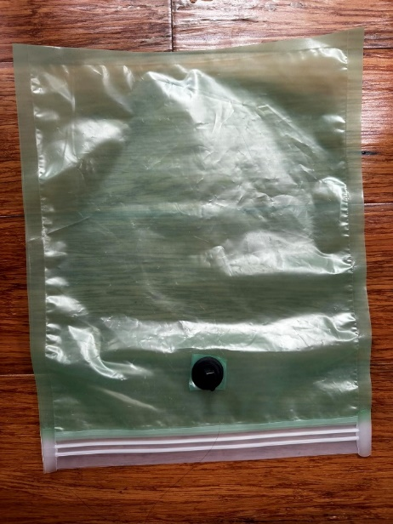

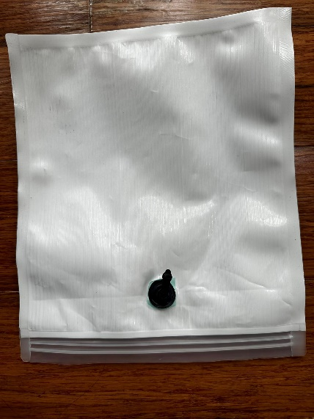

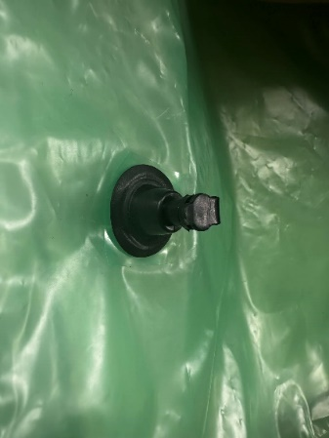

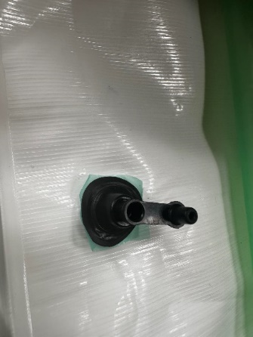

**Fabrication of Sensors**

The sensors that will be used to measure the parameters of the condition of the fermentation bags and the mucilage will be fabricated using the Raspberry Pi processing unit. This will be used because it can sustain at a longer duration and its error is minimal compared to Arduino uno processing unit. In determining the temperature and humidity, DHT22 temperature and humidity sensor module. This module uses thermistor and capacitive humidity sensor to measure the conditions of the environment. The capacitor outputs digital signal, which serves as their quantitative measure, to the output pin. In measuring the CO2 level of the fermentation bag, MG811 Carbon Dioxide Gas CO2 Sensor Module will be used. Using this module, the CO2 threshold level will be set. Once the level exceeds the threshold, a digital signal (ON/OFF) will be released. In determining the pH level of the bag, the PH-4502C Liquid PH Sensor with E201-BNC Electrode will be used.

The readings of these sensors fabricated will be calibrated using the standard instruments.

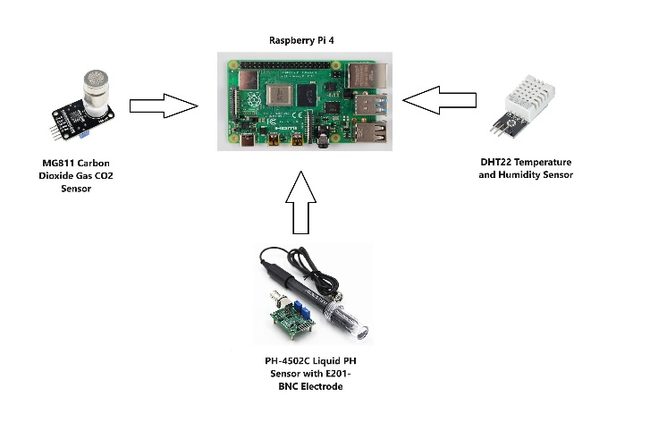

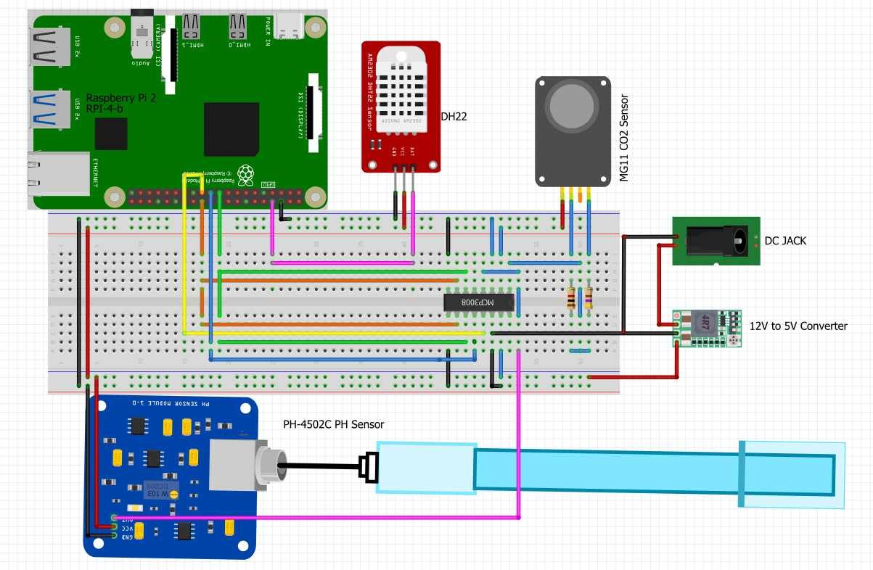

**Preparation of the Coffee Beans**

The coffee cherries (*Coffea excelsa*) will be harvested from the plantation of the National Coffee Research, Development, and Extension Center. There will be three treatments in terms of processing method for coffee cherries – unpulped, pulped without water, and the pulped with water. For the unpulped cherries, they will be washed thoroughly, be weighed, and be put in the fermentation bags. For the pulped beans, cherries will be washed thoroughly. After washing they will be depulped using a mechanical depulper. The pulped beans are then weighed and be put to the fermentation bags. For the treatment with water, the beans will be fully soaked with distilled water until the fermentation time ends. Each bag should contain 200 grams of unpulped cherries and pulped beans, respectively.

**Performance Evaluation of Coffee Fermentation Bags**

The performance of the two fermentation bags will be evaluated at three different bean processing (unpulped, pulped without water, and pulped with water), at two different room temperatures (20°C and ambient) and at eight different fermentation time (24, 48, 72, 96, 120, 144, 168, 192 hours).

During the process, the system (cherry or bean) temperature, CO2, O2, pH, and brix will be monitored. The temperature and moisture will be monitored all throughout the fermentation time using the DHT-22 sensors. The CO2 and O2 levels will be monitored using both the MG811 Carbon Dioxide Gas Sensor and GCMS-QP2020 NX Gas Chromatography while the pH using the PH-4502C Liquid PH Sensor. To evaluate the quality of beans on every fermentation time, the pH and temperature of the supernatant will be measured using the portable pH meter and food thermometer, respectively. The mass of the beans after each period will also be measured using the digital weighing scale to determine the amount of mucilage retained. The fermented beans will undergo washing and drying after each measurement. The parameters measured will be analyzed versus the fermentation time. Thus, pH curve, temperature curve, CO2 curve, O2 curve, and mass curve will be generated.

**Determination of the Green Coffee Bean Quality**

After fermentation, the beans will undergo drying until the moisture content reaches 12% as suggested by the Philippine Coffee Board. The dried beans processed will be evaluated based on color, uniformity, and grade. These parameters are determinant of green coffee bean quality (Philippine National Standard for Green Coffee Bean, 2023). The color will be measured using the portable colorimeter, the uniformity and grading will be done using manual process or through the utilization of Image J.

**Determination of the Roasted Coffee Bean Quality**

The dried green coffee will undergo roasting process. This process is very crucial since it will determine the overall quality of the coffee beverage. The roasted coffee beans will be evaluated with its quality parameters; namely, pH, total soluble solids, and coffee cupping score.

The pH and the total soluble solids of coffee beverage will be evaluated using the portable pH meter and refractometer, respectively. The coffee cupping score will be evaluated by a qualified Coffee Q Grader based on the parameters shown at Table 1.

Table 1. Quality Parameters for Roasted Coffee Beans

|  |
| --- |
| **Quality Parameters** |
| a. Fragrance (quality and intensity) |
| b. Aroma (quality and intensity) |
| c. Acidity (quality and intensity) |
| d. Body (quality and intensity) |
| e. Flavor (quality) |
| f. Aftertaste (quality) |
| g. Balance (quality) |
| h. Sweetness (yes/no presence) |
| i. Uniformity (yes/no) |
| j. Clean cup (yes/no) |
| k. Overall rating (quality) |

**Economic Analysis of the Fermentation Bags**

To determine the feasibility of the research study, aside from the technical evaluation, the economic viability needs to be determined. The total costing of the fermentation bag will be evaluated. The costing includes the material and labor costs.

To determine the economic viability, the costs will be matched with the benefits to determine the internal rate of return, return of investment, and the benefit-cost ratio.